“BIOMETRIC VOTING MACHINE”

A Report submitted to
MSRIT
Bangalore
For partial requirement of award of degree of
Bachelor of Engineering in Electronics and Communication
By
KARTHIK DATT A 1MS08EC402
VISHWANATH BAGALKOT 1MS07EC119
MANJUNATHA D 1MS08EC403
THILAK BABU KS 1MS08EC409

Under the guidance of
Mr. C.G.RAGHAVENDRA,
Assistant Professor
M.S.R.I.T,
Bangalore-54



DEPARTMENT OF ELECTRONICS AND COMMUNICATION ENGG
MS RAMAIAH INSTITUTE OF TECHNOLOGY
(Autonomous Institute, Affiliated to VTU)
May 2011

CHAPTER 1
INTRODUCTION

INTRODUCTION:
The objective of voting is to allow voters to exercise their right to express their choices regarding specific issues, pieces of legislation, citizen initiatives, constitutional amendments, recalls and/or to choose their government and political representatives. Technology is being used more and more as a tool to assist voters to cast their votes. To allow the exercise of this right, almost all voting systems around the world include the following steps:
- voter identification and authentication
- voting and recording of votes cast
- vote counting
- publication of election results
Voter identification is required during two phases of the electoral process: first for voter registration in order to establish the right to vote and afterwards, at voting time, to allow a citizen to exercise their right to vote by verifying if the person satisfies all the requirements needed to vote (authentication).
Ancient archeological artifacts and historical items have been discovered to still retain a large number of fingerprints on them. Since this was a discovered significant stride in fingerprinting and identification have been made. In 1788 a detailed description of anatomical formations of fingerprints was made. Then in1823 fingerprints began to be classified into nine categories, (Handbook) and by the 19th century Sir Francis Galton had developed analytical methods for fingerprint matching. As the criminal justice system evolved, there arose the need for criminals to be uniquely identified by some physically identifiable trait. Richard Edward Henry of Scotland Yard began using fingerprinting in 1901 and its success eventually lead to its increased use in the law enforcement field
The field of biometrics was formed and has since expanded on to many types of physical identification. Still, the human fingerprint remains a very common identifier and the biometric method of choice among law enforcement. These concepts of human identification have lead to the development of fingerprint scanners that serve to quickly identify individuals and assign access privileges. The basic point of these devices is also to examine the fingerprint data of an individual and compare it to a database of other fingerprints.
Nearly everyone in the world is born with a fingerprint that is unique; a separate and comprehensively identifying attribute that sets us apart from the other 6.5 billon people that inhabit this world. It is because of this fact that the fingerprint has proven such a useful part of biometric security. The very reason that fingerprint scanners are useful can be found in this fact as well. However, this is far from the only reason they are used.
Another important reason fingerprint scanners are used is, they provide a quick, easy, efficient, and secure measure through which, an individual with the proper access privileges can authenticate. The fingerprint of an employee for example, is stored in a database that the scanner queries every time it is used. There are two basic Boolean conditions the scanner then goes through when an individual’s print is scanned. First, the print is usually searched for in a database of fingerprints, once it is found it then looks at the print to see what access privileges are associated with the print and compares them to the access they are trying to gain. If everything checks out the subject is allowed access and they are not otherwise. In any case, a log of the event is usually stored for security purposes the size of these devices is another reason they have become so mainstream recently. Fingerprint scanners can be deployed directly near a door for access or as a peripheral to a computer for logging in. Modern day scanners have even been embedded on computer keyboards, mice, and USB devices because engineers have been able to reduce their size. Fingerprint scanners are also very versatile in the function that they can serve. The most common use may be for access restriction; however, they have served as time clocks, personal data retrievers, and even to cut down on truancy in some schools. Since they have experienced so much success in these areas, businesses are expanding upon their use and they are getting more public exposure
Finger printing recognition, the electronic methods of recording and recognizing an individual finger print, advanced substantially during the last decade of the 21th century. Today, identification can be achieved in a few seconds with reasonable accuracy. As a result, the use of automated fingerprint identification systems (AFIS) that record, store, search, match and identify finger prints is rapidly expanding. AFIS can be integrated with a microcontroller and other peripherals to form an embedded system which is a comprehensive electronic voting machine with fingerprint print identification system.

CHAPTER 2
BLOCK DIAGRAM

BLOCK DIAGRAM

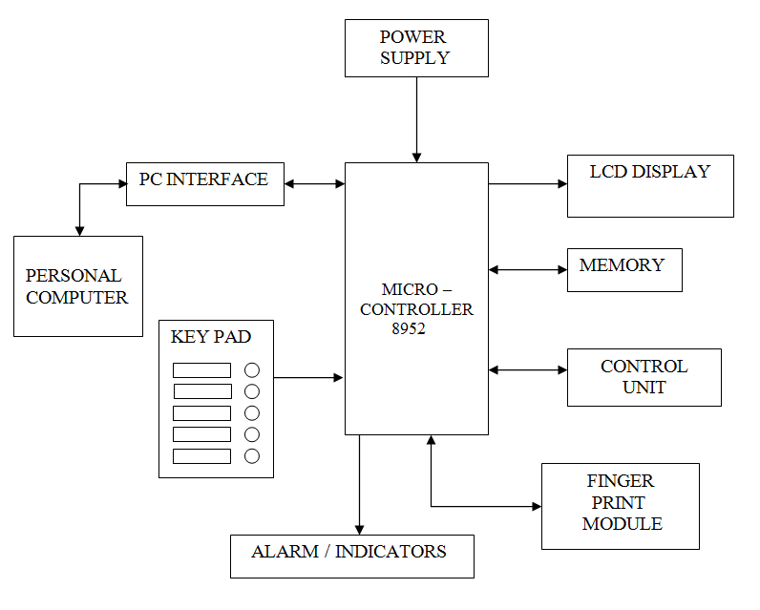

CHAPTER 3
HARDWARE DESCRIPTION:

HARDWARE DESCRIPTION:
Biometric Voting Machine hardware mainly contains a microcontroller, finger print module, eeprom, lcd display, PC interface, power supply, key pad. Each of the components are described below.
3.1:MICROCONTROLLER- AT89C52:
The 8952 microcontroller is upgraded version of 8051 family of microcontrollers. The 8051 microcontroller was introduced by Intel Corporation in the year 1981. It is an 8-bit microcontroller with Harvard Architecture manufactured by advanced CMOS processes. It has 128 bytes of on chip RAM, 4k bytes of on chip ROM, two 16-bit timers/counters, four 8-bit ports of which one is a serial port, etc. There are 6 interrupt sources also.
Since this is an 8-bit micro controller, the CPU can work on only 8 bits of data at a time. Data larger than 8 bits has to be broken down to 8 bit pieces. Though it has an addressing capability of 64 Kbytes, only 4k bytes have been provided on chip.
8051 is available in different memory types, such as UV-EPROM, FLASH, and NV-RAM. The UV-EPROM version of 8051 is the 8751. This chip has only 4K bytes of on chip UV-EPROM. To use this chip for development requires access to a PROM burner, as well as a UV-EPROM eraser to erase all the contents of UV-EPROM inside the 8751 chip before you can program it again. It takes about 20 minutes to erase the 8751 before it can be programmed again. This led to introduce FLASH and NV-RAM versions of 8051.
Another popular version of 8051 is DS5000 chip from Dallas Semiconductor. The on chip ROM is in the form of NV-RAM. The read/write capability of NV-RAM allows the program to be loaded into the on chip ROM while in the system. This can be done via a serial port of a PC. Another advantage of NV-RAM is the ability to change the ROM contents one byte at a time. The entire ROM must be erased before programmed again in the case of UV-EPROM and flash memory.
There are also OTP (One Time Programmable) versions of the 8051 available from different sources. Flash and NV-RAM versions are typically used for product development. When a product is designed and finalized, the OTP version of the 8051 is used for mass production since it is much cheaper in terms of price per unit.
There are two other members in the 8051 family of microcontrollers. They are the 8052 and the 8031.The 8052 has all the standard features of the 8051 in addition to an extra 128 bytes of RAM, an extra timer, extra 4K bytes of on chip ROM, and two more interrupt sources. Therefore all programs written for 8051 will run on 8052, but the reverse is not true.
8031 is often referred to as ROM-less 8051 since it has 0K bytes of on chip ROM. To use this chip we must add external ROM to it. The ROM containing the program attached to the 8031 can be as large as 64K bytes. For adding external ROM two ports are needed out of 4 ports, leaving only 2 ports for I/O operations. To solve this, external I/O ports like 8255 can be added to 8031. Atmel Corporation’s AT89C52is a low-power, high-performance CMOS 8-bit microcomputer with 8K bytes of Flash programmable and erasable read only memory (PEROM). The device is manufactured using Atmel’s high-density nonvolatile memory technology and is compatible with the industry-standard MCS-51 instruction set and pin out. The on-chip Flash allows the program memory to be reprogrammed in-system or by a conventional on volatile memory programmer. By combining a versatile 8-bit CPU with Flash on a monolithic chip, the Atmel AT89C52 is a powerful microcomputer that provides a highly flexible and cost-effective solution to many embedded control applications.
Flash memory can be erased in seconds compared to 20 minutes needed for 8751. For this reason 89C52 is used in place of 8751 to eliminate the waiting time needed to erase the chip and thereby speed up the development time. The development system requires a ROM burner that supports flash memory. The entire contents of ROM should be erased in order to program it again; the PROM burner itself does this. The 89C52 Flash reliably stores memory contents even after 10,000 erase and program cycles. AT89C52 is a popular chip of this category from Atmel Corporation.

The micro-controller generic part number actually includes a whole family of microcontrollers that have numbers ranging from 8031 to 8751 and are available in N-channel Metal Oxide Silicon (NMOS) and CMOS construction. 89c52 is an 8-bit micro-controller having 40 pins arranged as DIP packages. The features unique to micro-controllers include:
- INTERNAL RAM AND ROM
- I/O PORTS WITH PROGRAMMABLE PINS
- TIMERS AND COUNTERS
- SERIAL DATA COMMUNICATION

The 89C52 architecture consists of these specific features:
- Eight-bit CPU with registers A and B
- 16-bit program counter and data pointer
- 8-bit stack pointer
- Internal ROM of 8k
- Internal RAM of 128 bytes
- Four register banks each containing eight registers
- 16 bytes addressable at the bit level
- 80 bytes of general purpose data memory
- 32 input/output pins arranged as four 8 bit ports
- Three 16-bit timer/counter
- Full duplex serial data receiver/transmitter
- Control registers: TCON, TMOD, SCON, PCON, IP and IE
- Two external and three internal interrupt sources
- Oscillator and clock circuits

3.1.1:The internal layout of an 89C52:

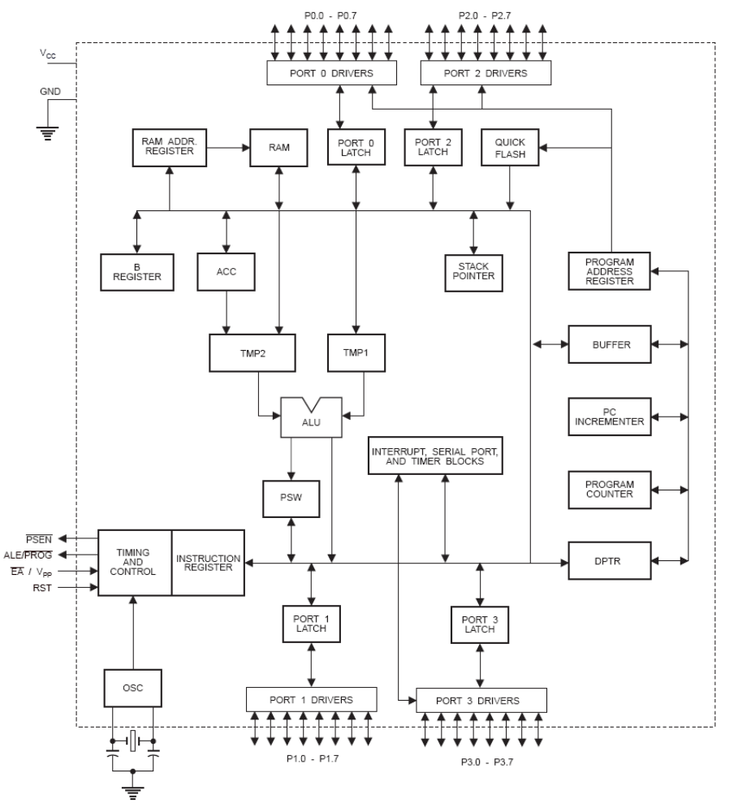

89C52 Oscillator and Clock
The heart of 89C51 is the circuitry that generates the clock pulses by which all internal operations are synchronized. Pins XTAL1 and XTAL2 are provided for connecting a resonant network to form an oscillator. The crystal frequency is the basic internal clock frequency of the micro controller.
Program Counter and Data Pointer
The 89C52 contains two 16 bit registers, the program counter and the data counter. Each is used to hold the address of byte in memory. Program instruction byte is fetched from location in memory that is addressed by the PC. The PC is automatically incremented after every instruction bytes fetched and may also be altered by certain instructions.
The DPTR register is made up of two 8-bit registers named DPH and DPL, which are used to furnish memory addresses for internal and external code access and external access. The DPTR is under the control of program instructions.
A & B CPU registers:
The A and B register holds results of many operations, particularly math and logical operations. The A register is also used for all data transfers between the 89C51 and any external memory.
Flags & Program Status Word:
Flags are 1 bit registers provided to store the result of certain program instructions. The flags are groups inside the program status word and the power control (PCON) registers. The 89C52 have four math flags that respond automatically to the result of math operation and three general-purpose user flags that can be set to 1 or cleared to 0 by the programmer as desired. The math flag include carry (C), Auxiliary Carry (AC), Overflow (OV) and Parity (P). User flags are named F0, GF0 and GF1; they are general purpose flags hat may be used by the programmer to record some event in the program.
The program status word contains the math flag, user program flag F0, and the register select bits identify which of the four general purpose register banks is currently in use by the program.
Internal Memory:
The 89C52 have internal RAM for program code bytes and for variable data that can be altered as the program runs. Additional memory can be added externally using suitable circuits. Unlike micro-controller with a Von Neumann architecture, which can use a single memory address for either program code or data, but not for both, the 89C52 have Harvard architecture, which uses the same address, in different memories, for code and data. Internal security accesses the correct memory based on the nature of operation in progress.
Internal RAM:
It had 128 internal RAM, which is organized, into distinct areas. 32 bytes from address 00H to 1FH that make up thirty two working registers organized as four bands of eight registers each. A bit addressable area of sixteen bytes occupies ram byte addresses 20H to 2FH. A general purpose RAM area above the bit area from 30H to 7FH addressable as bytes.
Stack and Stack Pointer:
The stack refers to an area of internal ram that is used in conjunction with certain op codes to store and retrieve data quickly. The eight-bit stack pointer register is used to hold an internal ram address called the top of the stack. The address held in the SP register is the location in the internal ram where the last byte of data was stored by a stack operation.
When data is to be placed on the stack the SP increments before storing data on the stack up grows, as data is stored. As data is retrieved from the stack, the byte is read from the stack, and then the SP decrements to point to the next available byte of stored data. The SP is set to 07H when the 89C52 is reset and can be changed to any internal ram addressed by the programmer.

Special Function Registers:
The 89C52 operations that do not use the internal ram address from 00H to 7FH are done by a group of specific internal registers each called special function registers, which may be addressed much like internal ram, using addresses from 8011 to FFH. Some SFR’s are also bit addressable. This feature allows the programmer to change only what needs to be altered, leaving the remaining bits in that SFR unchanged.
Input/ Output pins, Ports and Circuits:
One major feature of a micro-controller is the versatility built into the IO circuits that connect the 89C52 to external world. Four ports are provided in 89C52 to connect to the outside world. Different functions are associated with a single port. The function of a port is decided by a hardware circuit connected and software commands used to program it under the complete control of a program designer.
Each port has a D type output latch for each pin. The SFR of each port are made up of these eight latches, which can be addressed at the SFR address for that port. The port latch should not be confused with the port pins. The data on the latch does not have to be the same as that on the pins. The status of each latch may be read from a latch buffer; while an input buffer is connected directly to each pin status may be read independently of the latch state. Different op codes accesses the latch or pin states as appropriate. Port operation is determined by manner in which microcontroller is connected to the external circuitry.
The two data paths are shown in figure while circuits that read the latch or pin data using two entirely separate buffers. The output buffer is enabled when the latch data is read and the lower buffer when the pin state is read.
Programmable port pins have completely different alternate functions. The configuration of the control circuitry between the output latch and the port pins determines the nature of any particular port pin function. Only one port cannot have alternate function. Port 0, 2, 3 can be programmed.
Port0: serves as input/output or bidirectional lower order address and data bus for external memory.
Port1: have no dual functions. It can be used as input/output.
Port2: serves as input/output or bidirectional higher order address and data bus for external memory.
Port3: can be used as input/output, for serial communication and various other alternative uses. The port3 alternate uses are given below

Pin | Alternate Use | SFR
P3.0 – RXD | Serial data input | SBUF
P3.1 – TXD | Serial data output | SBUF
P3.2 – INT0 | External interrupt 0 | TCON.1
P3.3 – INT1 | External interrupt 1 | TCON.3
P3.4 – T0 | External timer 0 input | TMOD
P3.5 – T1 | External timer 1 input | TMOD
P3.6 – WR | External memory write pulse
P3.7 – RD | External memory read pulse

3.1.2:Counters and Timers:
Many microcontroller applications require the counting of external events such as frequency of pulse train, or the generation of precise internal time delays between computer actions. Three sixteen bit counters named T0,T1and T2 are provided for general use of the programmer. Each counter may be programmed to count internal clock pulses acting as a timer or program to count external pulses as a counter.
The counters are divided into eight bit registers called the timer low (TL0, TL1) and high (TH0, TH1) bytes. All counter actions is controlled by bit status in the timer mode control registers TMOD, the timer/counter control register TCON, and certain program instructions.
TMOD is dedicated entirely to the timer and can be considered to be two duplicate 4 bit registers, each of which controls the action of one of the timer. TCON has the control bits and flags for the timer in the upper nibble, control bits and flags for external interrupts in the lower nibble.
Timer Counter Interrupts:
The timers have been included on the chip to relieve the processor of timing and counting chores. When the program wished to count a certain number of internal pulses or external events, a number is placed in one of the counters. The number represents the maximum count less the decide count, plus 1.The counter increments from the initial number to the maximum and then roles over to 0 on the final pulse and also set a timer flag. The flag condition may be tested by an instruction to tell the program that the count has been accomplished, or the flag may be used to interrupt the program.
Timing:
If a counter is programmed to be a timer, it will count the internal clock frequency of the oscillator divided by 12d. The resultant timer clock is gated to the timer. The bit TRX in the TCON register must be set to one (timer run), and the gate counter is configured as a timer, then the timer pulses are gated to the counter by the bit and gate bit or the external input bits INT.
Timer Modes of Operation:
The timers may be operated in one of the four modes that are determined by the mode bits. M1 and M0 in the TMOD register.
Timer mode 0:
Setting timer X mode bits to 00B in the TMOD register results in using the THX register as an eight bit counter and TLX as a five bit counter; pulse input is divided by 32d in TL so that the TH counts the original oscillator reduced by a total 384d.
Timer mode 1:
Mode 1 is similar to mode 0 except TLX is configures as a full 8 bit counter, When the mode bits are set to 01B in the TMOD. The timer flag would be set in 1311 seconds using a 6MHz crystal.
Timer mode 2:
Setting the mode bits to 10b in the TMOD configures the timer to use only the TLX counter as an eight bit counter. THX is used to hold a value that is loaded into TLX every time TLX overflows from FFh to 00h. The timer flag is also set when TLX overflows. This mode exhibits and auto reloaded feature: TLX will count up from the number in THX, overflow, and be initialized again with the contents of THX.
Timer mode 3:
Timer 0 and 1 may be programmed to be in mode 0.1,2 independently of a similar mode for the other timer. This is not true for mode3; the timer does not operate independently if mode 3 is chosen for timer0. Placing timer 1 in mode3 causes it to stop counting; the control bit TRI and the timer flag TF1 are then used by timer 0. Timer 0 in mode 3 becomes two completely separate eight bit counters. TL0 is controlled by the gate arrangement and sets the timer flag TF0 whenever it overflows from FFh to 00h. TH0 receives the timer clock (the oscillator divided by 12) under the control of TRI only and set the TF1 flag when it overflows.
Timer 1 may be still used in modes 0,1 or 2 while timer 0 is on mode 3 with one important exception: the timer 1 will generate no interrupts while timer 0 is using the TF1 overflow flags. Switching timer 1 to mode 3 will stop it and hold whatever count is in timer1.
Counting:
The only difference between counting and timing in the source of the clock pulses when used as a timer, the clock pulses are sourced from the oscillator through the divide by 12d circuit: when use as counter pint T0 supplies pulses to counter 0 and pin T1 to counter1. Each high and low states of the input pulse must be held constant for at least one machine cycle to ensure reliable counting.
Interrupts:
Interrupts are hardware signals that force a program to call a subroutine. Interrupts take up the processor time only when the action by the program is needed. Interrupts are often the only way in which real time programming can be done successfully.
Interrupts may be generated by internal chip operation or by external sources. Any interrupt can cause the microcontroller to perform a hardware call to an interrupt handling subroutine that is located at a pre determined absolute address in the program memory. Five interrupts are provided in the 8051. Three of these are generated automatically by interrupt (R1 or T1). Two interrupts are triggered by external signals provided by circuitry that is connected to pins INT0 and INT1.
All interrupts are under the control of the program. The programmer is able to alter the control bits in the Interrupt Enable register (IE), the Interrupt Priority register (IP) and the Timer Control register (TCON). The program can block all or any of the combinations of the interrupt from acting on the program by suitable setting or clearing of these registers. After the interrupts has been handled by the interrupt subroutine, which is placed by the programmer in the interrupt location in the program memory, the interrupt program must resume operation at the instruction where the interrupt take place. Program resumption is done by storing the interrupted PC address on the stack in ram before changing the PC to the interrupt address in ROM. The PC address will be stored from the stack after an RETI instruction is executed at the end of the interrupt subroutine.
Timer Flag Interrupt:
When a counter/timer slashes overflow, the corresponding timer flag TF0 or TF1 is set to one. The flag is cleared to 0 when the resulting interrupt generates a program call to the appropriate timer subroutine in the memory.
External Interrupts:
Pins INT0 and INT1 are used by external circuitry. Inputs on these pins can set the interrupt flags IE0 and IE1 in the TCON register to 1 by two different methods. The IEX flag may be set when the INTX pin reached a low level or the flags may be set when a high to low transition takes place on the INTX pin. Bits INT0 and INT1 in TCON program the INTX pins for low level interrupt when set to 0 and program the INTX pins for transition interrupt when set to 1. Flags IEX will be reset when the processor accepts the transition generated interrupt and the interrupt subroutine is accessed. The external circuits must remove the low level before an RETI is executed.
Reset:
This can be considered as the ultimate interrupt as the program cannot block the action of the voltage at the RST pin. This type of interrupt is often called non maskable interrupt (NMI). Unlike other interrupts, the PC is not stored for later program resumption.
Interrupt Control:
The IE register holds the programmable bits that can enable or disable all the interrupts as a group, or if the group is enabled, each individual interrupt source can be enabled or disabled. The IP register bits, may be set by the program to assign priorities among the various interrupts sources so that more important interrupts can be serviced first.

3.2:SM630 FINGERPRINT MODULE

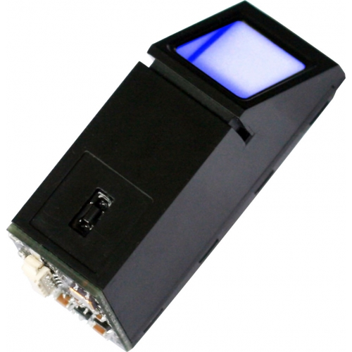

3.2.1: SM630 features
SM630 background highlight optical fingerprint verification module is the latest release of Miaxis Biometrics Co., Ltd. It consists of optical fingerprint sensor, high performance DSP processor and Flash. It boasts of functions such as fingerprint Login, fingerprint deletion, fingerprint verification, fingerprint upload, fingerprint download, etc. Compared to products of similar nature, SM630 enjoys the following unique features:

- Self-proprietary Intellectual Property

Optical fingerprint collection device, module hardware and fingerprint algorithm are all self developed by Miaxis.

- High Adaptation to Fingerprints

When reading fingerprint images, it has self-adaptive parameter adjustment mechanism, which improves imaging quality for both dry and wet fingers. It can be applied to wider public.

- Low Cost

Module adopts Miaxis’ optical fingerprint collection device, which dramatically lowers the overall cost.
- Algorithm with Excellent Performance

SM630 module algorithm is specially designed according to the image generation theory of the optical fingerprint collection device. It has excellent correction & tolerance to deformed and poor-quality fingerprint.

- Easy to Use and Expand

User does not have to have professional know-how in fingerprint verification. User can easily develop powerful fingerprint verification application systems based on the rich collection of controlling command provided by SM630 module. All the commands are simple, practical and easy for development.

- Low Power Consumption

Operation current <80mA, specially good for battery power occasions.

- Integrated Design

Fingerprint processing components and fingerprint collection components are integrated in the same module. The size is small. And there are only 4 cables connecting with HOST, much easier for installation and use.

- Perfect Technical Support

Miaxis is the leading company in the fingerprint verification industry. It has an excellent customer service team ready to offer powerful technical support in user development.

3.2.2: TECHNICAL SPECIFICATIONS:
Operating Voltage:

4.3V～6V

Rating Voltage:

6.5V（exceeding this value will cause permanent damage to the module）

Operating Current：

<80mA（Input voltage 5V）

Fingerprint Template：

768 templates

Search Time：

<1.5s（200 fingerprint, average value in test）

Power-on Time：

<200ms（Time lapse between module power-on to module ready to receive instructions）

Tolerated Angle Offset：

±45°

User Flash Memory：

64KByte

Interface Protocol:

Standard serial interface （TTL level）

Communication Baud Rate:

57600bps
Operating Environment:

Temperature: -10 °C～+40°C

Relative humidity: 40％RH～85％RH（no dew）

3.2.3: ELECTRICAL INTERFACE:

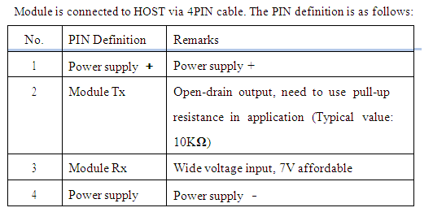

3.2.4: COMMAND:
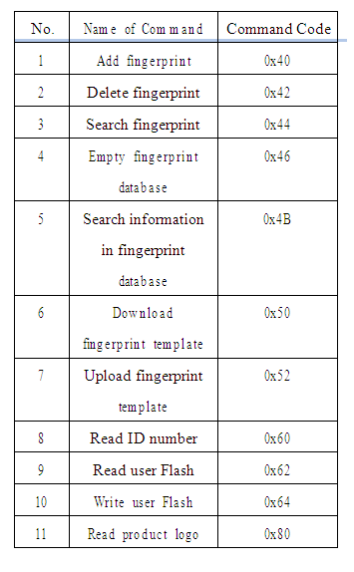

3.2.5: RESPONSE CODE:
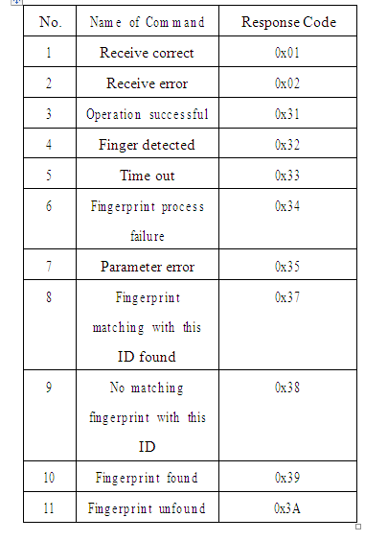

3.2.6: EXAMPLES:

Add fingerprint:
Description: Add fingerprint at the designated position.
Length：3 bytes
Format： Command code 0x40 + high byte of the to-be-added fingerprint ID |  | + low
byte of the to-be-added fingerprint ID.

For example：

1 .HOST sends command to add fingerprint at position 0: 0x4D + 0x58 + 0x10 + 0x03 + 0x40 + 0x00 + 0x00 + 0xF8
2. Module responds by receive correct: 0x4D + 0x58 + 0x30 + 0x01 + 0x01 + 0xD7

3. First time to press finger. Module will respond as operation successful after processing the first fingerprint:

0x4D + 0x58 + 0x30 + 0x02 + 0x40 + 0x31 + 0x48

4. Press finger again, and module will respond as operation successful after processing:

0x4D + 0x58 + 0x30 + 0x02 + 0x40 + 0x31 + 0x48

Remarks：

1. Fingerprint ID starts from 0

2 .Fingerprint storage capacity: 768

3. If the ID is wrong in the command, module will responds as parameter error:
0x4D + 0x58 + 0x30 + 0x02 + 0x40 + 0x35 + 0x4C

4. If user press different finger at the first time and second time, or the fingerprint quality is poor, module will responds as fingerprint processing failure:

0x4D + 0x58 + 0x30 + 0x02 + 0x40 + 0x34 + 0x4B

5. If there is no finger pressing within 10 seconds, module will respond as time-out.

0x4D + 0x58 + 0x30 + 0x02 + 0x40 + 0x33 + 0x4A

Delete Fingerprint:

Description: Delete the fingerprint of designated ID.

Length：3 bytes

Format： Command code 0x42 + high bytes of the to-be-deleted fingerprint ID + low bytes of the to-be-deleted fingerprint ID.

For example:

1. HOST sends command to delete fingerprint ID No. 0;

0x4D + 0x58 + 0x10 + 0x03 + 0x42 + 0x00 + 0x00 + 0xFA

2. Module responds as RX correct:
0x4D + 0x58 + 0x30 + 0x01 + 0x01 + 0xD7

3. Module responds as operation successful after execute the fingerprint deletion command:

0x4D + 0x58 + 0x30 + 0x02 + 0x42 + 0x31 + 0x4A

Remarks：

1. If fingerprint ID in the command is out of range, module will respond as parameter error:

0x4D + 0x58 + 0x30 + 0x02 + 0x42 + 0x35 + 0x4E

Search Fingerprint:

Description: Searching for designated fingerprint within range

Length：5 bytes

Format： Command code 0x44 + search high bytes of starting ID + search low bytes of low bytes + high bytes of the number of fingerprints searched + low bytes of the number of fingerprints searched

For example：

1. HOST sends command to search 16 fingerprints starting from 0:

0x4D + 0x58 + 0x10 + 0x05 + 0x44 + 0x00 + 0x00 + 0x00 + 0x10 + 0x0E

2. When the fingerprint is placed on the sensor window, module will respond as operation successful:

0x4D + 0x58 + 0x30 + 0x02 + 0x44 + 0x31 + 0x4C

3. If the fingerprint is found, module will return the following:

0x4D + 0x58 + 0x30 + 0x04 + 0x44+ 0x39 + high bytes of ID for the found fingerprint + low bytes of ID for the found fingerprint + check sum

4. If no matching fingerprint is found, module will return the following:
0x4D + 0x58 + 0x30 + 0x02 + 0x44 + 0x3A + 0x55

Remarks：

1. The number of the fingerprints that are searched starts from the ID of the first fingerprint, for example, the search starts from fingerprint ID 0. the number of fingerprints searched is 0x10，then the fingerprint ID actually being searched is 0～ 0x0F, altogether 0x10 fingerprints.

2 If the ID in the command is wrong, module will responds as parameter error:
0x4D + 0x58 + 0x30 + 0x02 + 0x44 + 0x35 + 0x50

3.If the fingerprint quality is poor, module will respond as fingerprint processing failure:

0x4D + 0x58 + 0x30 + 0x02 + 0x44 + 0x34 + 0x4F

4. If there is no finger placing on the sensor with 10 seconds, module will respond as time out:
0x4D + 0x58 + 0x30 + 0x02 + 0x44 + 0x33 + 0x4E
3.3: EEPROM-24C08:
E²PROM became necessary, as we had to store the database of voters. When an voter votes, the details of the voter, along with the system time, are stored into the memory chip. Vote obtained for each candidate is also stored in eeprom. This can be later downloaded to a computer using the user-friendly front-end software developed in Labview
We use AT24C08 EEPROM having 8K memory and 1 million write cycle capacity. The AT24C08 provides 8192 bits of serial electrically erasable and programmable read-only memory (EEPROM) organized as 1024 words of 8 bits each. The device is optimized for use in many industrial and commercial applications where low-power and low-voltage operations are essential. This is a serial device, data entering and reading being serial. The data retention is guaranteed for a 100 years. This is connected to port pins of microcontroller.
3.4: I²c bus interface:
It makes use of I²C bus interface with microcontroller, which stands for inter-inter computer communications. The standard was originally developed by Philips in late 1970s as a method to provide an interface between microprocessors and peripheral devices without writing full address, data, and control buses between devices. I²C is the most efficient and popular serial communication standard. Two wires, serial data (SDA) and serial clock (SCL), carry information between the devices connected to the bus. The simple 2-wire serial I²C-bus minimizes interconnections; so ICs have fewer pins.(AT 24C01 comes in an 8 pin dip package)

Pin Assignment for AT24C08:
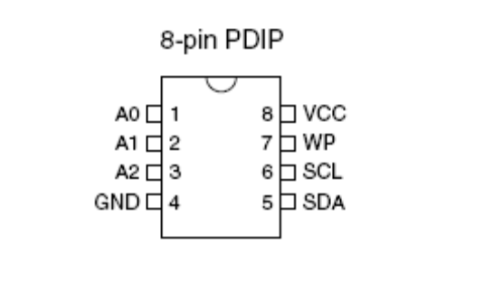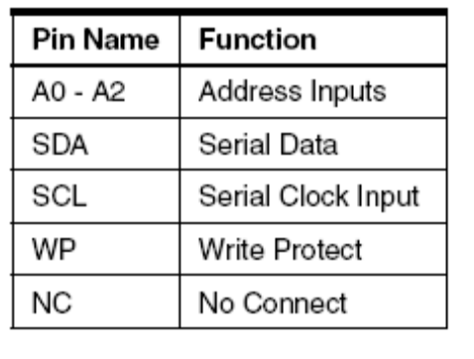

Pin Descriptions:
SERIAL CLOCK (SCL): The SCL input is used to positive edge clock data into each EEPROM device and negative edge clock data out of each device.
SERIAL DATA (SDA): The SDA pin is bi-directional for serial data transfer. This pin is open-drain driven and may be wire-OR ed with any number of other open-drain or open-collector devices.
WRITE PROTECT (WP): The AT24C08 has a Write Protect pin that provides hardware data protection. The Write Protect pin allows normal read/write operations when connected to ground (GND). When the Write Protect Pin is connected to VCC; the write protection feature is enabled.
DEVICE/PAGE ADDRESSES (A2, A1, A0): The AT24C08 only uses the A2 input for hardwire addressing and a total of two 8K devices may be addressed on a single bus system. The A0 and A1 pins are no connects.

3.5:LCD DISPLAY- JHD204A:

The LCD display panel is used to display status messages and error messages. DMC series is the name given to the dot matrix character LCD display modules that have been developed by Shenzhen Jing Handa Electronics Co., Ltd.
The modules consist of high contrast and large viewing angle TN and STN type LC (liquid crystal) panels. Each module contains a CMOS controller and all necessary drivers which have low power consumption. The controller is equipped with an internal character generator ROM, RAM and RAM for display data. All display functions are controllable by instructions making interfacing practical.
Both display data RAM and character generator RAM can be read making it possible to use any part not used for display as general data RAM. The products of this series therefore have wide application possibilities in the field of terminal display or display for measuring devices.
Parameter:
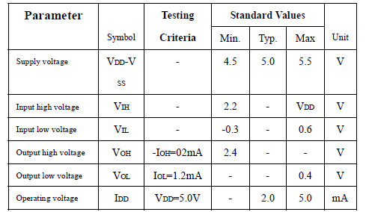

Pin Descriptions:
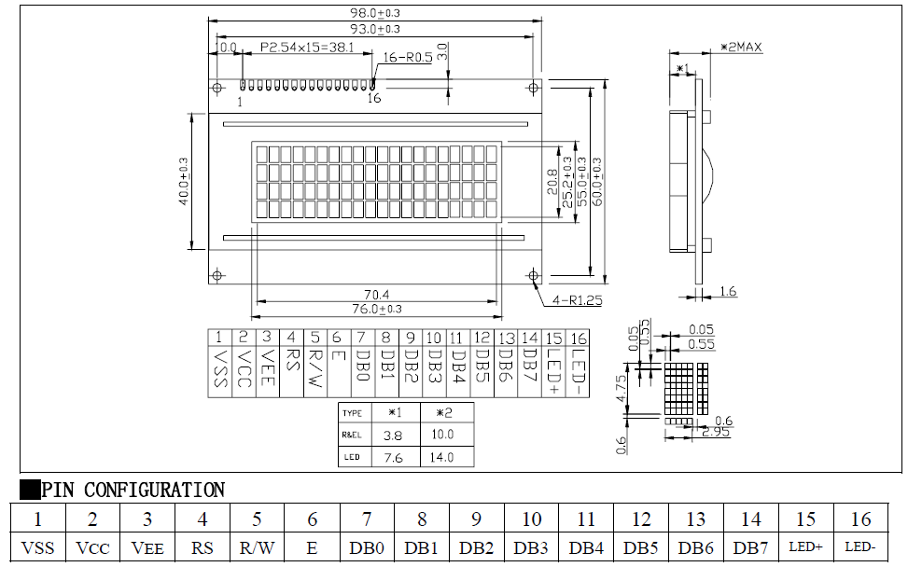
The detailed datasheet of dispaly is given at the Appendix of this report.

3.6: SERIAL COMMUNICATION-RS232:

RS-232 is simple, universal, well understood and supported but it has some serious shortcomings as a data interface. The standards to 256kbps or less and line lengths of 15M (50 ft) or less but today we see high speed ports on our home PC running very high speeds and with high quality cable maxim distance has increased greatly. The rule of thumb for the length a data cable depends on speed of the data, quality of the cable. Electronic data communications between elements will generally fall into two broad categories: single-ended and differential. RS232 (single-ended) was introduced in 1962, and despite rumors for its early demise, has remained widely used through the industry. Independent channels are established for two-way (full-duplex) communications. The RS232 signals are represented by voltage levels with respect to a system common (power / logic ground). The "idle" state (MARK) has the signal level negative with respect to common, and the "active" state (SPACE) has the signal level positive with respect to common. RS232 has numerous handshaking lines (primarily used with modems), and also specifies a communications protocol.
The RS-232 interface presupposes a common ground between the DTE and DCE. This is a reasonable assumption when a short cable connects the DTE to the DCE, but with longer lines and connections between devices that may be on different electrical busses with different grounds, this may not be true. RS232 data is bi-polar.... +3 TO +12 volts indicate an "ON or 0-state (SPACE) condition" while A -3 to -12 volts indicates an "OFF" 1-state (MARK) condition.... Modern computer equipment ignores the negative level and accepts a zero voltage level as the "OFF" state. In fact, the "ON" state may be achieved with lesser positive potential. This means circuits powered by 5 VDC are capable of driving RS232 circuits directly, however, the overall range that the RS232 signal may be transmitted/received may be dramatically reduced.
The output signal level usually swings between +12V and -12V. The "dead area" between +3v and -3v is designed to absorb line noise. In the various RS-232-like definitions this dead area may vary. For instance, the definition for V.10 has a dead area from +0.3v to -0.3v. Many receivers designed for RS-232 are sensitive to differentials of 1v or less.This can cause problems when using pin powered widgets - line drivers, converters, modems etc. These type of units need enough voltage & current to power them self's up. Typical UART (the RS-232 I/O chip) allows up to 50ma per output pin - so if the device needs 70ma to run we would need to use at least 2 pins for power. Some devices are very efficient and only require one pin (some times the Transmit or DTR pin) to be high - in the "SPACE" state while idle.
An RS-232 port can supply only limited power to another device. The number of output lines, the type of interface driver IC, and the state of the output lines are important considerations. The types of driver ICs used in serial ports can be divided into three general categories: Drivers which require plus (+) and minus (-) voltage power supplies such as the 1488 series of interface integrated circuits. (Most desktop and tower PCs use this type of driver.) Low power drivers which require one +5 volt power supply. This type of driver has an internal charge pump for voltage conversion. (Many industrial microprocessor controls use this type of driver.)
3.7: KEYPAD:
The system is designed to accommodate five candidates. The key pad used for the system contains five keys and correspondingly five LEDs. There is a special key which is for display total no of vote polled so far.
3.8: Power supply:
Power supply unit consists of the following units:
- Step down transformer
- Rectifier unit
- Input filter
- Regulator unit
- Output filter
Step down transformer: It is used to step down the main supply voltage by using step down transformer. It consists of primary and secondary coils. The o/p from the secondary coil is also AC wave form. So we have to convert the easy wave form into dc voltage by using rectifier unit.
Rectifier UNIT: We have to convert Ac voltage to DC using rectifier. Bridge rectifier is used. This o/p voltage often rectifier is in rippled form, so we have to remove ripples from DC voltage.
Input FILTER: Capacitor acts as filter. The principle of the capacitor is charging and discharging. It charges in the positive half cycle of the AC voltage and it will discharge in the negative half cycle. So this allows only AC voltage and does not allow the DC voltage. This filter is fixed before the regulator.
Regulator unit: Regulator regulates the o/p voltage constant depends on upon the regulator. It is classified as follows.
- Positive regulator
  - Input pin
  - Ground pin
  - Output pin
It regulates the positive voltage
- Negative regulator
  - Ground pin
  - input pin
  - output pin
It regulate the negative voltage

Output filter: Capacitor acts as filter. The principle of the capacitor is charging and discharging. It charges in positive half cycle of the AC voltage an it will discharge in negative half cycle. So it allow only allows AC voltage and does not allow the DC voltage. This filterer fixed after the regulator.

CHAPTER 4
CIRCUIT DIAGRAM

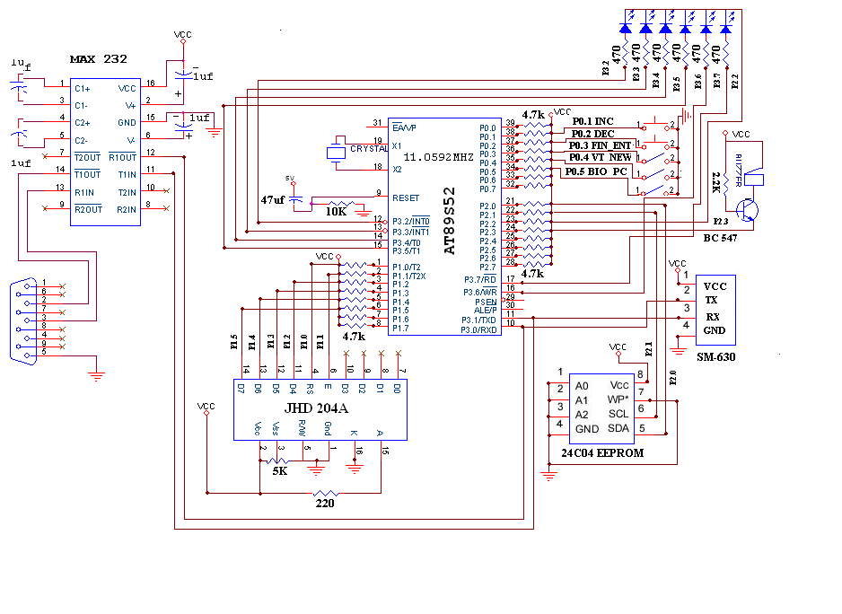 WORKING OF CIRCUIT:
Supply Section of this circuit consists of a 12 volts adaptor, and a IC 7805 IC. The output of the second regulator(IC 7805) is +5 volts, which is used for all other digital applications.
The voting machine consists of six keys, which are connected to six separate pins of microcontroller. Port pins P3.2 to P3.7.Which are usually made high to act as input port and other side of key is connected to P2.2 which acts as active high input in order to disable the keypad until interrupt occurs.
The display section uses the port 1 of microcontroller. This port is in open drain configuration and as a result, pull up resistors should be provided for its normal operation. The contrast of this LCD display is adjusted by changing the value of a resistor which is grounded at the other end.
A Buzzer is used to indicate whether a voter has exercised his vote correctly and also for recognizing any malpractice during the whole process. This buzzer is connected to a supply of +5 volt by means of a pull up resistor.
The EEPROM IC 24C08 is a serial electrically erasable and programmable read-only memory. It is connected to microcontroller through two pins SDA and SCL. This EEPROM is used to store the details relating to the voter and indicating whether a voter has already voted or not and also the date and time of voting.
SM630 device operates at 57600 baudrate which is achieved by setting TH1 and TL1 register to FFH in auto reload mode by which we can achieve baudrate of 28800 and by setting MSB of PCON register to high we can double the baudrate to 57600.
SM630 has 4 pins Vcc, gnd ,Tx and Rx.The Tx of SM630 is connected to serial receive input of microcontroller which is nothing but P3.0 pin. Similarly Rx of SM630 is connected to serial transmit pin of microcontroller P3.1.
RS-232 which is a simple, universal and well understood standard is applied in this project. It converts the active high condition of PC(-3 volt to -12 volt) to the active high condition of the microcontroller(+5 volt) and vice versa. Similarly the active low condition of the microcontroller ( 0 volt) is transformed to the active low condition of the PC (+3volt to +12volt) and act as a perfect means of interfacing microcontroller and PC.MAX 232 is used in the serial communication to convert RTL to TTL.

CHAPTER 5
SOFTWARE

5.1: FLOWCHART
Start
Initialize ports for LCD as O/P ports , Buzzer as O/P ports,Inc,dec, switches as I/P & vote_new, party_keys, Pc_Bio_mode, finger_entry switch as I/P port

Enable UART Receive Interrupt
Configure Timer0 for Baud Rate 57,600 bps

On Reset if PC_Bio Mode==0
No

If PC_Bio_mode==1
On Reset if S1==0
Transmit candidates number _of_votes & citizen Vote report to the PC
Erase E2PROM memory locations

no

yes
C

no

yes
If vote_new==0

no
B

yes
Display on LCD “ENTER ID”
A
IF Inc==0 switch
A

no

yes
Increment the ID by 1

If Dec==0 switch
If S1==ON

no no

yes
Decrement the ID by 1

MCU sends the packet to Biometric to register the finger print in entered ID

Is any data received from Biometric interrupted

no

yes
Store the received packet in buffer

Is RX packet==success packet

no

yes
yes
LCD Display as ‘Enroll Sucess’

LCD Display as ‘Enroll Failure’
C
STOP
B
Place the finger
MCU Sends the packet to Biometric to search the finger

Is Any data Received from Biometric Interrupted
(UART RX)

No

Yes
Store the Rx packet in Buffer

Is Rx packet in Buffer == matched finger print

No
Display ‘FAKE VOTER’

Yes
Display on LCD the Voter’s ID

Display on LCD “Vote for the party”
Is Respective Party’s vote switch==1

No

Read E2PROM location of the party & Increment it by 1

Store the Updated vote to the E2PROM location of the party
C
STOP

FRONT END DESIGN:
Visual Basic (VB) is the third-generation event-driven programming language and integrated development environment (IDE) from Microsoft for its COM programming model. Visual Basic is relatively easy to learn and use.
Visual Basic was derived from BASIC and enables the rapid application development (RAD) of graphical user interface (GUI) applications, access to databases using Data Access Objects, Remote Data Objects, or ActiveX Data Objects, and creation of ActiveX controls and objects. Scripting languages such as VBA and VBScript are syntactically similar to Visual Basic, but perform differently.
A programmer can put together an application using the components provided with Visual Basic itself. Programs written in Visual Basic can also use the Windows API, but doing so requires external function declarations.
The final release was version 6 in 1998. Microsoft's extended support ended in March 2008 and the designated successor was Visual Basic .NET (now known simply as Visual Basic).
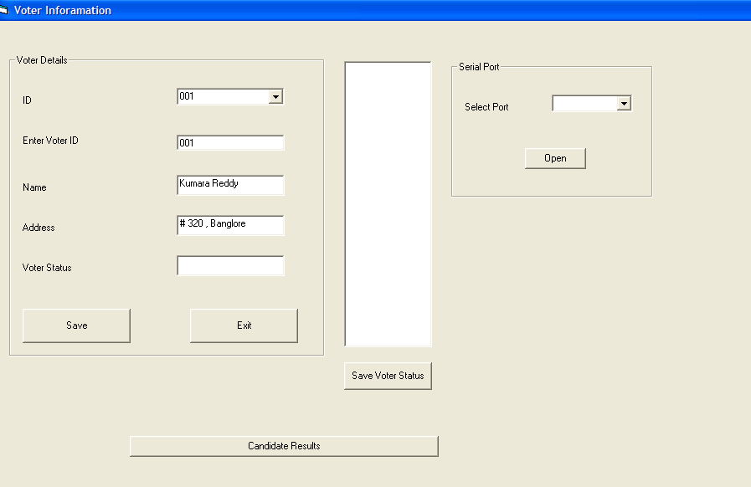

Candidate Results:
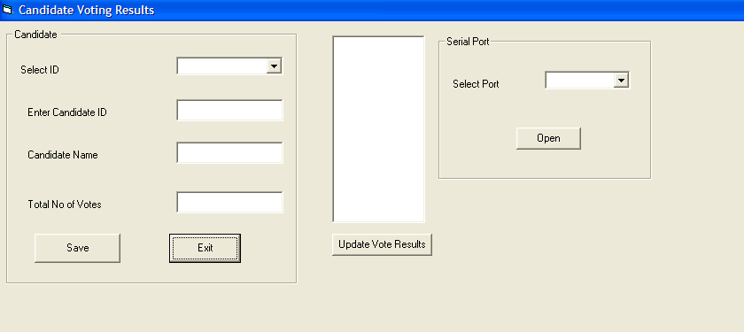
Data Base Results:
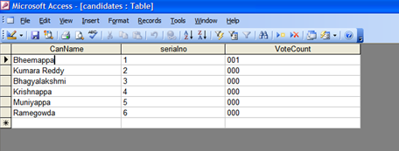

PROBLEMS FACED AND MODIFICATIONS:
- The RS232 IC got heated due to flow of reverse current to the circuit from the pc.
- We faced problem in setting baudrate for SM630 which operates at 57600 baudrate and later it was modified.
- SM630 responses in no time which the microcontroller is unable to read , so we used interrupts to store and then read the data as required.

FUTURE MODIFICATIONS:
- Memory of finger print module can be expanded .We can use a 1mb flash memory finger print module for increasing the capacity.
- External memory can be provided for storing the finger print image, which can be later accessed for comparison.
- Smart Card reader module is supposed to be introduced with the existing module for further security, and to reduce the database storage.
- Audio output can be introduced to make it user friendly for illiterate voters.
- Retina scanning can also be developed.

APPENDIX

Data sheet of 8051(Important parts only):
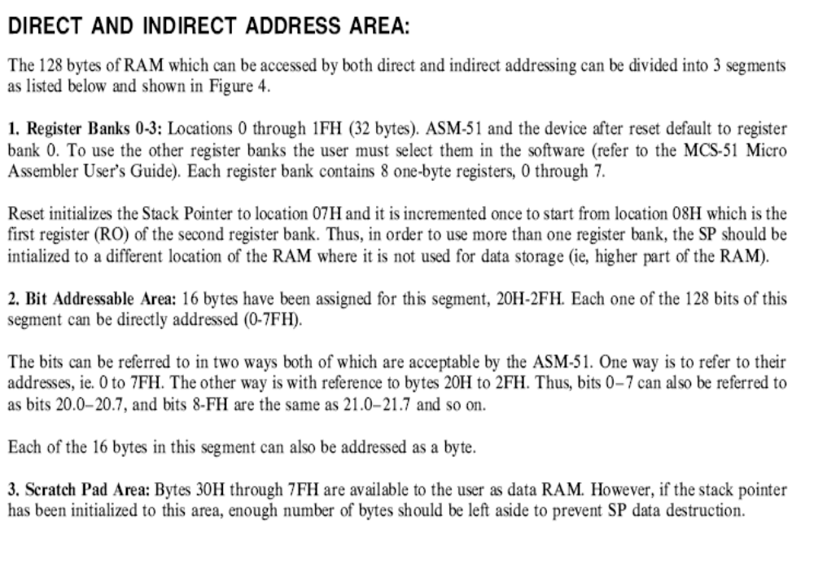

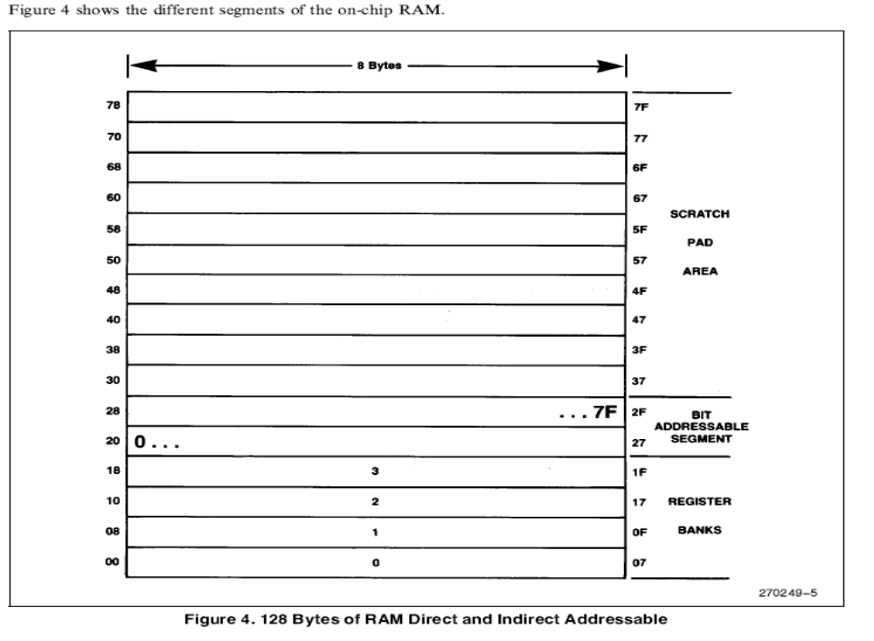
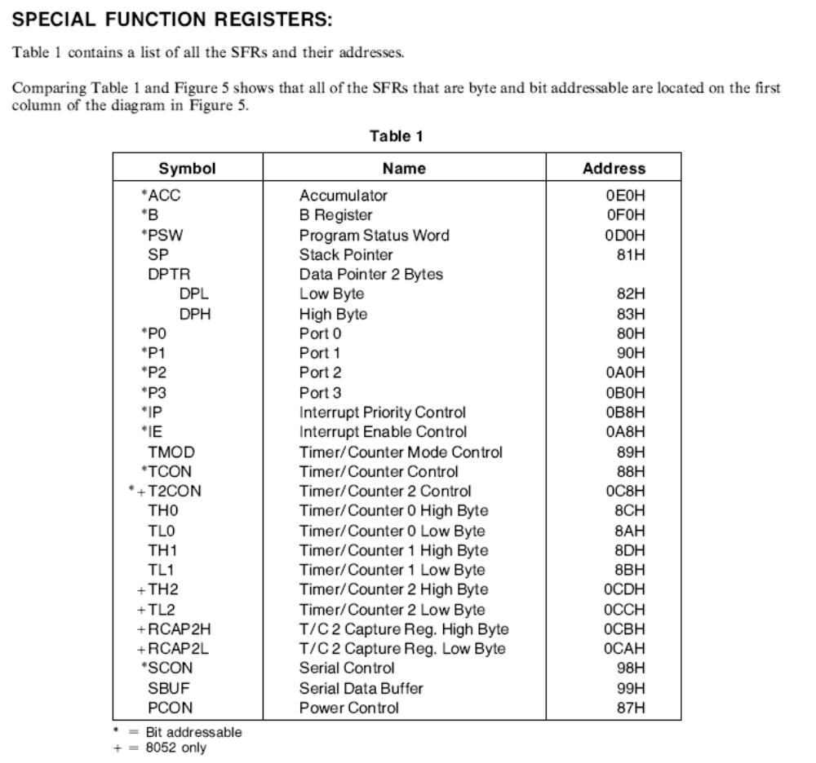
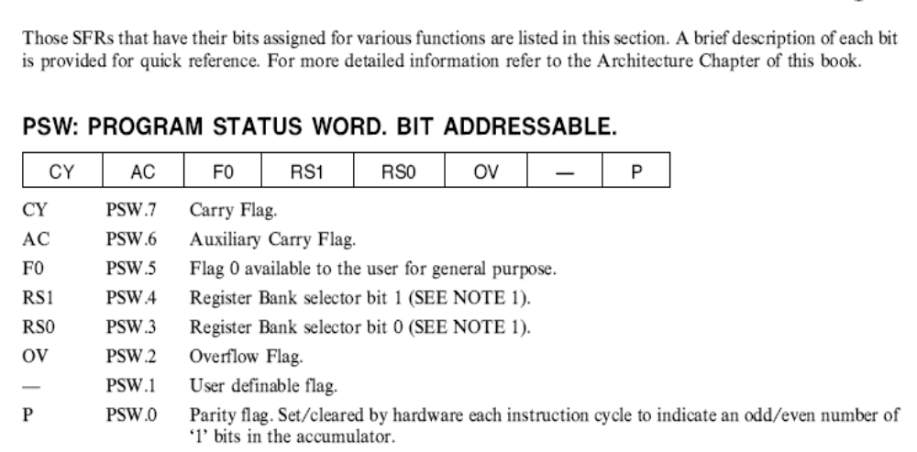
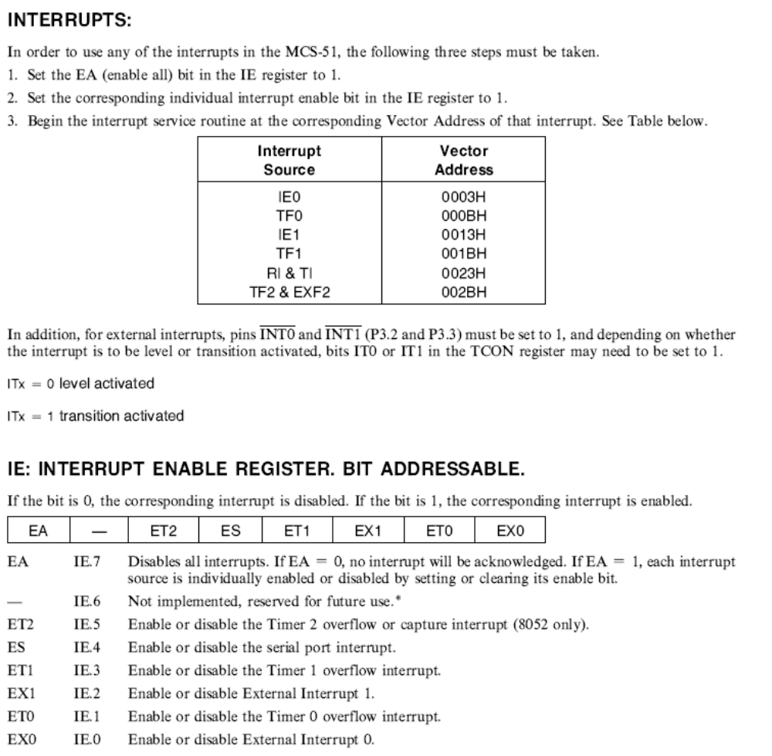
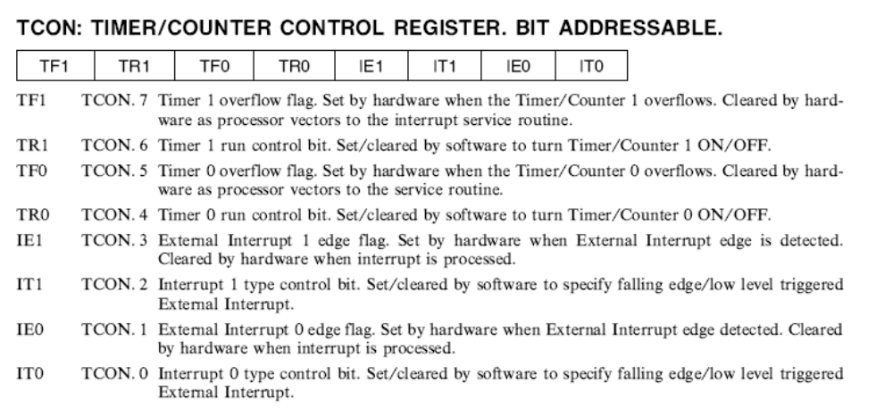
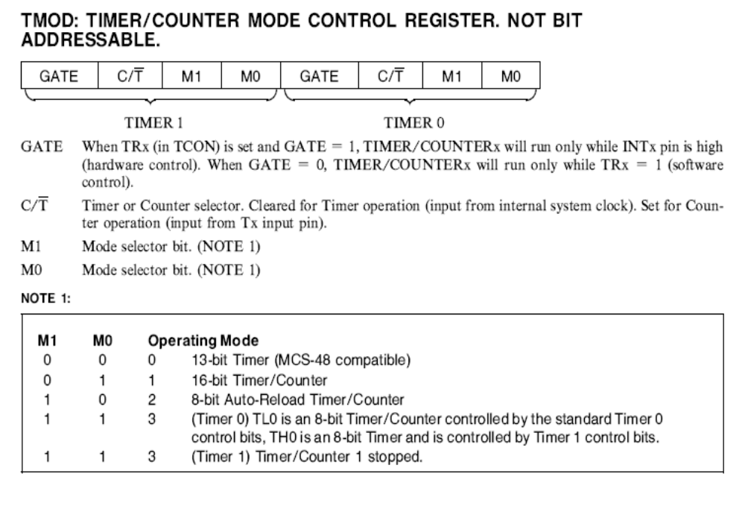

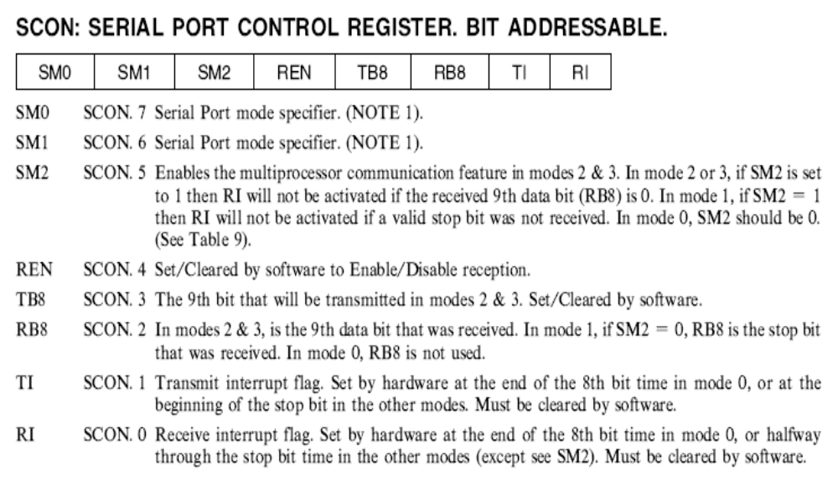
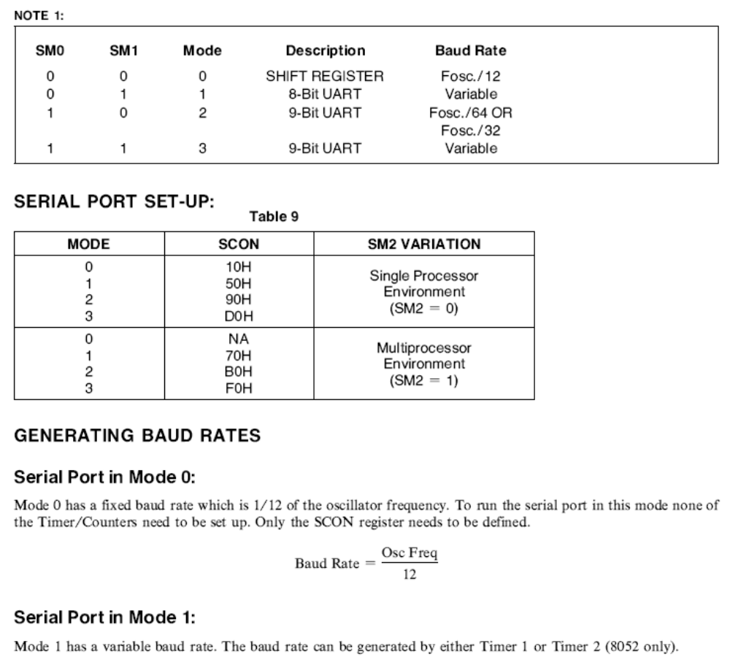
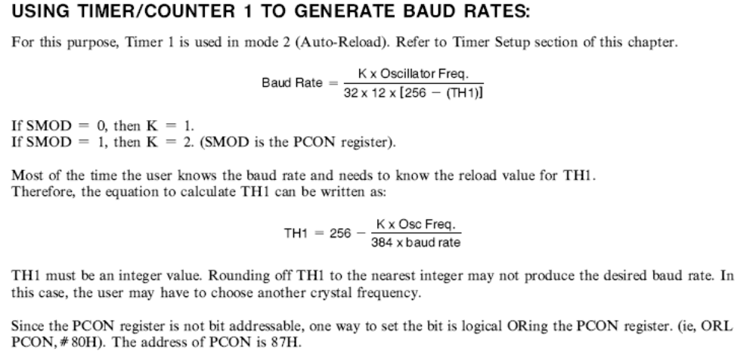

BIBILOGRAPHY
Reference websites:
www.atlmel.com
www.suprema.com
www.8052.com
www.keil.com

Reference books:
1. The 8051 Microcontroller and Embedded Systems, by Ali Mazidi & Gillispie Mazidi.
2. Embedded Microprocessor Systems: Real World Design by Stuart R. Ball
3. Interfacing with C, Second Edition by Howard Hutchings and Mike James

